Invitation to a press tour of the RAY MASTER CLASS exhibition at the Museum Angewandte Kunst

Press Information

Frankfurt am Main / 22 September 2021

Dear members of the press

we would like to invite you to a **press tour** of the **RAY MASTER CLASS exhibition** at the Museum Angewandte Kunst on **Wednesday, 29 September 2021 at 3 PM**. The number of participants is limited so please register in advance via [presse@ray2021.de](mailto:presse@ray2021.de). The guided tours will be held by the students who worked on the exhibition with RAY artist Johanna Diehl and will be happy to answer any open questions.

The results of the **RAY MASTER CLASS** can be seen at the **Museum Angewandte Kunst** until **9 January 2022**. Johanna Diehl developed the exhibition "Essays of Undoing" together with 13 students from universities of the region. The MASTER CLASS is a cooperation between RAY and the Hochschule für Gestaltung Offenbach, the Hochschule Darmstadt, the Kunsthochschule Mainz and the Hochschule für Bildende Künste - Städelschule. Another exhibition is planned for 2022 at the **Opelvillen Rüsselsheim**. The RAY MASTER CLASS is supported by the **Crespo Foundation**. Prof. Christiane Riedel, board member of the Crespo Foundation will also be on site at the Museum Angewandte Kunst on 29 September.

“The interesting thing about photography, however, is that it is not just a serving medium for ideological rhetoric and products, but also a medium that can lead to a distribution of the sensible (Jacques Rancière), that can be political. Therefore, the notion that images and image-making have the potential to make sense of the world, and that photography can be assumed to have its own form of thinking, is at the heart of the RAY MASTERCLASS that I am leading. Furthermore, especially in times of ideological intensification and the terror of the same (Byung-Chul Han), there must always be a decided subjectivity, an attitude of one's own and an ethic of image-making, as well as the "imposition" not to simplify the complexity of reality, but to leave it in the picture.” — Johanna Diehl

The **RAY 2021 IDEOLOGIES exhibition at the Museum Angewandte Kunst** can also be visited **until 9 January 2022.** The photographic and cinematic works shown at the Museum Angewandte Kunst, deal directly or indirectly with historical abuses and the media image of “Africa”. **Yagazie Emezi, Mohau Modisakeng and Yves Sambu** present an exploration of gender, poverty, beauty, the body, identity and the consequences of racism for the individual and the community, all drawn from within African societies.

[For more information and press images, visit:](https://ray2021.de/presse/)

<https://ray2021.de/en/press/>

We look forward to welcoming you!

Natali-Lina Pitzer

Press & Public Relations RAY Photography Projects Frankfurt/RheinMain

presse@ray2021.de M +49 (0)175 - 9461068

On behalf of Fotografieprojekte gGmbH

Braubachstraße 30–32 • 60311 Frankfurt • info@ray2021.de • [www.ray2021.de](http://www.ray2021.de/)

RAY 2021 Fotografieprojekte Frankfurt/RheinMain is a cooperation between Art Foundation DZ BANK, Deutsche Börse Photography Foundation, Fotografie Forum Frankfurt, Museum Angewandte Kunst, Museum MMK für Moderne Kunst, Historisches Museum Frankfurt, Kunstforum der TU Darmstadt, Kunst- und Kulturstiftung Opelvillen Rüsselsheim, Marta Hoepffner-Gesellschaft für Fotografie e.V. im Stadtmuseum Hofheim, Museum Giersch der Goethe-Universität and Nassauischer Kunstverein Wiesbaden. The international Triennial RAY Fotografieprojekte Frankfurt/RheinMain was founded in 2010 on the initiative of the Kulturfonds Frankfurt RheinMain to bundle and highlight the outstanding potential of artistic photography in the Frankfurt/Rhine-Main region.

RAY 2021 is made possible by

Share:02 AKTUELLE PROJEKTE:FGP. Förderkreis Fotografieforum Frankfurt:FGP.091 Ray 2018 Basiselemente:02_Ressourcen:Partnerlogos:KFRMLogo_final.eps  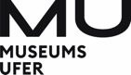­

Supported by

 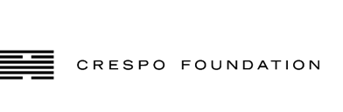 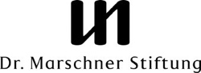

With further support by

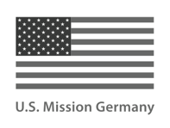 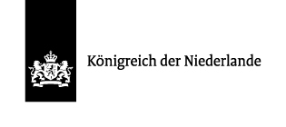

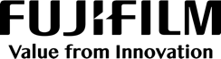 

Media partners

  

  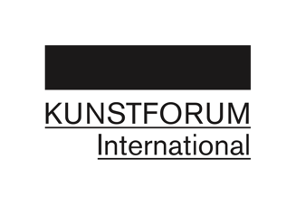

Sponsors

 